UWIDEC APC P. 8

2004/2005

THE UNIVERSITY OF THE WEST INDIES

An eLearning Proposal

This paper is submitted to the APC for its consideration by the University Director of Information Technology.

An eLearning Proposal

by Carlton A. Samuels, University Director of IT and CIO, Mona
& Craig A. Perue, Instruction Support Systems Coordinator, Mona
August 26, 2004

EXECUTIVE SUMMARY
We are not educationalists; we depend on our colleagues in the School of Education - and elsewhere - to collaborate and provide those skills. We submit, however, that we are experts in applying technology to solve workday problems. In our business, those that succeed at this task are diligent about understanding - or seeking to understand - the business for which they intend to devise solutions. Consequently, we have been hard at work in the last two (2) years at this academy learning this business.

The principal business of this academy is the development and delivery of education services which follows the plan enunciated by the strategic managers. Being ICT practitioners in this academy, we are very conscious of our roles in implementing the goals of the UWI Strategic Plan 2000 - 2007. As we seek to support the principal business of the University, we also take our cues from the pronouncements of our senior strategic managers. The Principal, PVC Professor the Honourable Kenneth O. Hall, is clear that the University of the West Indies at Mona is a ‘dual mode’ instruction institution. Dual mode in this case counts the traditional face-to-face instruction modality plus any other than face-to-face. His has been a consistent voice for transformation and change. Our Vice Chancellor, Professor the Honourable Rex Nettleford, insists that the University of the West Indies has always been and is, of fact, a ‘mixed mode’ institution. His deliberate choice of this phrasing is instructive and its import is not lost on us. In many ways and in various places, they have both recognized that ICT is on point and in the vanguard for change. We, as practitioners therefore, can do no less than respond.

Having been instructors and learners at one time or other, we have sought to develop a framework of action which is consonant with our responsibilities for online course development and learning conferred by the institutional strategic plan and instructed by the Principal’s Strategic Initiatives for the Mona Campus. We have diligently combed and digested the relevant literature, roamed the exhibit halls of numerous symposia and technology showcases seeking out the latest ideas on using ICT for teaching and learning and imbibing the best practices for its deployment from the experts and those that have gone the path before our institution. In the final analysis, we hold that:

- Multi-channel learning is highly effective
- There must be a framework for action consistent with the needs and strategies of the academy
- Using multimedia technologies for teaching aids retention and enhances learning
- Developing quality learning objects consistently requires a process that must integrate technology, people and practices
- eLearning is both cost effective and efficient
- The Internet is a cost effective delivery platform for eLearning

This paper seeks to enlist the support of the Academic Board, stepwise, towards the acceptance of online learning objects as an alternate way to deliver teaching in the University, that it may be used in conjunction with or exclusive of the traditional face-to-face modality and is worthy of equal standing in the academic community.
INTRODUCTION
The objective of this paper is to convince the Academic Board to adopt a simple, comprehensive normative methodology for categorizing, designing, developing, delivering and evaluating online courses. This Proposal does not make recommendations regarding ownership of the intellectual property produced, or provisioning of the resources to produce online courses. This Proposal is a technical and pedagogical guide, not a guide to the business of eLearning.

The University of the West Indies has enunciated a commitment to infusing the teaching-learning processes with appropriate information and communications technologies. Some of the reasons for doing so have been discussed and are being discussed in various fora. Rather than attempt to outline these reasons here - reasons many of you are already convinced of - we will take it as a given that the Academic Board is in general agreement with the need for these infusions, and focus here on expounding a simple, comprehensive methodology for designing, developing, and evaluating eLearning courses. We have distilled this methodology after reviewing copious amounts of the relevant literature, including the related Standards, participation in conventions and symposia, visits to other universities involved in eLearning, and reflecting on the UWI’s own processes, procedures, and practices for course development and quality control as embodied in various artefacts produced by the Office of the Board for Undergraduate Studies, the Board for Non-Campus Countries and Distance Education, the academic departments and various support units on the Mona Campus including the Instruction Support Systems (ISS) unit of Mona Information Technology Services (MITS).

We begin by defining the term “eLearning.” Next we launch directly into the suggested design processes, followed by a review of the development processes and conclude by examining the evaluation processes.

DEFINITIONS
“eLearning” has many meanings to many persons. Some of the meanings given over time are electronic learning, enhanced learning and enabled learning. From the perspective of our students, they want their learning to be easy, exciting and effective. Moreover, they expect information and communications technologies (ICT) to enable and enhance the teaching-learning system. That is their understanding of eLearning.

Two concepts seem to recur in attempts to discuss and define eLearning – innovation in teaching-learning, and the use of ICT for teaching-learning. The United Kingdom Department for Education and Skills’ contracted consultation paper, Towards a Unified e-Learning Strategy (July 2003), offers the following two definitions:
- If someone is learning in a way that uses information and communication technologies (ICTs), they are using e-learning. They could be a pre-school child playing an interactive game; they could be a group of pupils collaborating on a history project with pupils in another country via the Internet; they could be geography students watching an animated diagram of a volcanic eruption their lecturer has just downloaded; they could be a nurse taking her driving theory test online with a reading aid to help her dyslexia – it all counts as e-learning.
- E-learning exploits interactive technologies and communication systems to improve the learning experience. It has the potential to transform the way we teach and learn across the board. It can raise standards, and widen participation in lifelong learning. It cannot replace teachers and lecturers, but alongside existing methods it can enhance the quality and reach of their teaching, and reduce the time spent on administration. It can enable every learner to achieve his or her potential, and help to build an educational workforce empowered to change. It makes possible a truly ambitious education system for a future learning society.
Having embraced these generic definitions, let us now examine the different ways in which the UWI at Mona practices eLearning.

eLearning AT UWI MONA
Over the last two years instructors on the Mona campus have used ICT to support their courses in three primary ways:

- To enhance the delivery of lectures
- To enhance communication between instructors and students, and among students
- To provide asynchronous access to course materials

The Multimedia Lecture theatres and portable multimedia equipment that we have provided over the last three years have helped to enhance the delivery of lectures with very positive response from students who find the audio-visual presentations (frequently done in PowerPoint) more interesting and stimulating than a plain lecture. Campus Pipeline, our portal platform, has been used to provide for each course a message board, chat room, class calendar and email. Some instructors also provide worksheets, past papers, supplementary notes and handouts via course websites. A common characteristic of these courses is the significant face-to-face contact in formal lectures and tutorials, and the inclusion of electronic tools and components which merely supplement the face-to-face contact. These types of courses are termed Internet-supported courses.

In AY 2003-2004, the Mona campus worked on several Internet-based courses. These courses differ from Internet-supported courses in that all the course content usually delivered in face-to-face lectures are placed online and the “time-on-task” emphasis usually given to face-to-face contact is replaced with a corresponding emphasis on working in the online environment. In the last academic year, at least two such courses were delivered on the Mona Campus – one by Dr Faisal Butt from the Department of Geography and Geology in the first semester, and one by Drs Tomlin Paul and Janet LaGrenade from the Dept of Community Health and Psychiatry. Both courses received positive responses from the students who stated almost unanimously that they greatly preferred this mode of teaching-learning. An additional twenty-four Internet-based courses have been designed by the Instruction Support Systems unit (ISS) of MITS in close collaboration with members of the Faculty of Humanities and Education and the Faculty of Pure and Applied Sciences to be delivered as part of the B.Ed. Secondary (Distance) Education in the first semester of AY 2004-2005.

In addition to supporting the Internet-based courses mentioned above, ISS has extended collaboration with the Department of Community Health and Psychiatry, and begun collaborating with the Departments of Economics, Advanced Nursing Education, and Modern Languages and Literatures to produce several Internet-optimized courses. These courses share with Internet-based courses a “time-on-task” emphasis on the online components rather than face-to-face interaction, but are formally designed using the principles of instructional design and the inherent characteristics of the Internet as a teaching tool – inter alia, its open, distributed, dynamic, globally accessible, filtered, interactive, and archival nature – to maximize the effectiveness of the teaching-learning opportunities (Elliot & McGreal, 2002). To date, ISS and its collaborators have placed four (4) Internet-optimized courses in production; fourteen (14) others are substantially complete but lagging from delayed SME input.

The deployment of various ICTs over the last five years has in many cases positively affected the student experience, but as Britain and Liber noted in their February 2004 report “A Framework for the Pedagogical Evaluation of eLearning Environments” to the UK’s Joint Information Systems Council, pedagogical innovation and improvement in the quality of teaching and learning has been relegated. Whereas both Internet-supported and Internet-based courses improve the student experience and can help to increase the number of students the UWI can support, they do not address the core issues of the quality of teaching and learning which have been brought to the fore by Strategic Challenges Confronting UWI Mona: An Analysis and Response and the Discussion Paper on the UWI Graduate: Some Considerations and a Proposal, both of which were considered here in AY 2003-2004.

Internet-optimized courses focus on pedagogical innovation and improving the quality of teaching-learning, directly supporting the recommendations of the Wint Committee and Prof. Kenneth Hall’s call in January 2004 for more research in the scholarship of teaching-learning. Furthermore, the methodology for producing Internet-optimized courses expounded in this paper, provide enabling and supporting mechanisms for the curriculum review called for by the Office of the Board for Undergraduate Studies and endorsed by the Academic Board in its February 2004 response.

The crucial distinction that must be made between Internet-based and Internet-optimized courses is not about the quantum of technology employed but the frank difference in expectation as we employ the technologies. Whereas Internet-based courses are electronic transcripts of lectures, whether PowerPoint presentations, text documents or web pages, or print-based distance education materials, Internet-optimized courses are designed using an explicit quality-enhancing, multimedia instructional design methodology; the objective of which is to transform the face-to-face or print-based DE course by exploiting the inherent characteristics of the new modes of teaching and media which mediate the teaching-learning transactions. It is not our intent to hype this modality; we do not consider it a panacea. But we are convinced that properly architected and produced, Internet-optimized courses empower instructors, heads of departments and Deans to execute significant positive increases in effectiveness, efficiency, capacity, and prestige for the institution -… one course, one programme, one department at a time.

Let us be clear: MITS’ strategic position is to provision and support all three of Internet-supported, Internet-based and Internet-optimized courses as part of the eLearning paradigm and economy at the UWI. However, by virtue of its potential to deliver on the various objectives recognized in the numerous writings on capacity building with quality, we are unambiguously and preferentially disposed to Internet-optimized course development and deployment. Hence, this proposal recommends a standard and procedures for the design, development and evaluation of Internet-optimized courses.

CONCEPTUALIZING THE DIFFERENCES
The concepts of Internet-supported, Internet-based, and Internet-optimized courses may be represented as sets as in Diagram 1 below. The universal set, U is the set of all Mona courses, while the set of Internet-supported courses is set A. The set of Internet-based courses is set B, with its subset C representing the set of Internet-optimized courses.

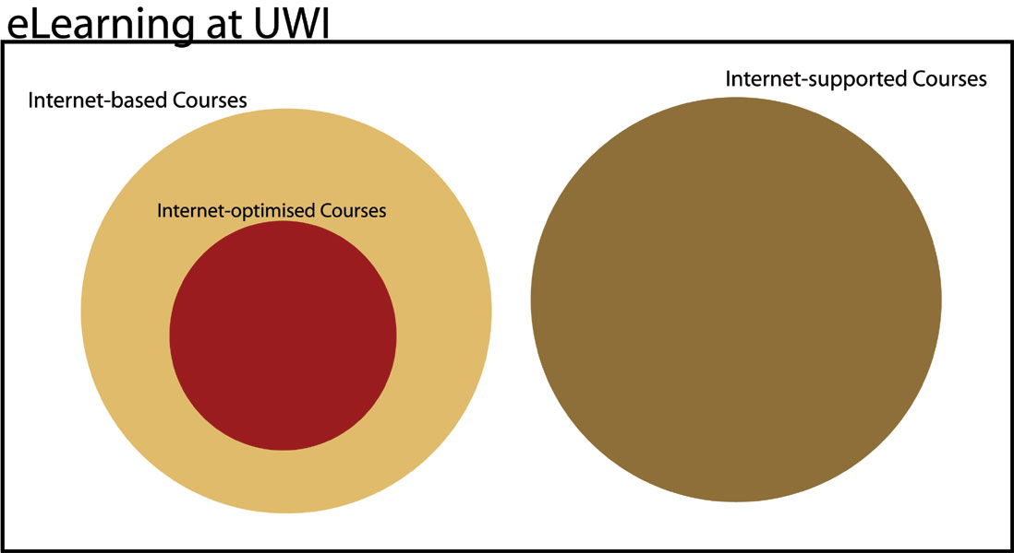

MANY TECHNOLOGIES – NOT JUST THE INTERNET
Having distinguished among the Internet-supported, Internet-based, and Internet-optimized courses according to the degree to which the courses harness the potential of information and communications technologies allied to the evolving educational theories, it is now important to mention some of these technologies. A useful framework for discussing these technologies was inspired by the pedagogical learning cube proposed by Nishikant Sonwalkar of MIT’s Academic Media Production Services in the November and December 2001 issues of Syllabus. The visual below was developed using his descriptions then enhanced and developed by ISS. On the x-axis of the pedagogical learning cube are the media elements – such as text, graphics, audio, video, animation and simulation, while the interactivity technologies – such as email, discussion groups, facsimile, telephone, instant messaging, chat rooms, video conferencing, whiteboards, and 3D virtual reality worlds are listed on the y-axis, and the learning models – apprenticeship, incidental, inductive, deductive and discovery are listed on the z-axis.

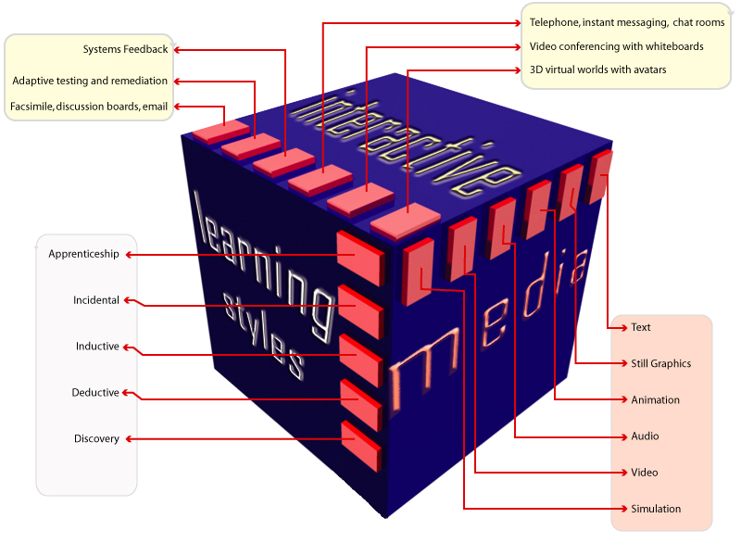

Media elements are different from the media technologies that support them, such as textbooks, radio, video cassettes, cable television, CD and DVD-ROMs. We make this distinction because we wish to emphasize that the methodology we here propose for producing Internet-optimized courses neither exclude nor relegate the use of these media technologies.

These mature media technologies continue to play very important niche roles in Internet-optimized courses. Thus, the Internet supports all the media elements listed above (to a greater or lesser extent) and is also a collection of interactivity technologies that has no doubt influenced its meteoric rise to stardom in modern life. Notwithstanding, we continue to maintain that textbooks, radio and cable television are excellent and usually cost-effective ‘broadband’ technologies for distributing content and facilitating dialogue between each student and the content. Hence, Internet-optimized courses frequently require the use of a variety of educational technologies to facilitate students’ success.

COURSE DESIGN CONTEXT
Course design and development need to take place within a carefully designed context. In endorsing the six competencies proposed for the UWI graduate profile as advanced in the Discussion Paper on the UWI Graduate: Some Considerations and a Proposal, the Mona Academic Board has set about creating that context. These competencies are not discipline specific but are what PVC Professor Hilary Beckles, Anthony Perry and the late Peter Whitely might have set forth in The Brain Train: Quality Higher Education and Caribbean Development (2002) as the “generic post-industrial skills” which, they wrote, are demanded of graduates of higher education institutions in the 21st century. In addition to those competencies, each discipline needs to synthesize what is described in Quality Assurance at the University of the West Indies: The Self Assessment 3e (1999) as “Aims and Objectives.” However, whereas the example of Objectives (also known as learning outcomes) presented as Appendix 2 of that document are the Objectives of an entire department – which quite likely offers several degrees at both the undergraduate and graduate levels – the authors suggest that departments need to synthesize Objectives for particular programmes of study, to provide programme and course designers with a more concrete context within which to design and evaluate programmes and courses. The objectives or learning outcomes that the authors think would be most useful for providing a context for programme and course design are defined according to The Brain Train (p. 110) by the UK Quality Assurance Agency (QAA) as “what knowledge, understanding, skills and other attributes a student will have developed on successfully completing a specific programme.” Development of such objectives would also enable easier equivalency articulation agreements with higher education institutions of the UK in the future. Some such “subject benchmarking” exercises have already begun between the UK education authorities and the European Union; the EU Ministers of Education signed the Bologna Declaration in 1999, which refers to the adoption of “a system of easily readable and comparable degrees.”

We have now established that objectives need to be developed for each programme to provide a well developed context within which courses may be developed. We shall not make detailed suggestions on creating programme objectives here since that is not this paper’s focus. Suffice to say, it is now generally accepted as best practice that a range of stakeholders external to the University need to be involved in designing any programme; and that a market need for the programmes should be established in the first instance.

How will the objectives and the graduate profile competencies be used in course design? Mantz Yorke, Professor of Higher Education at Liverpool John Moore’s University, puts it well when he states that the ideal curriculum “arguably involves a combination of ‘learning X’ and ‘learning through X’, such that teaching methods often address both at the same time.” While the objectives represent core content and skills that our academic staff are most familiar in teaching - “learning X” - frequently through didactic methods, the graduate profile competencies expresses that which is generally “learned through X”, such as the development of interpersonal skills within a small group assigned to investigating the impact of internationalization on higher education within the English-speaking Caribbean. We therefore posit that the choice of teaching-learning methods suggested by the curriculum or Learning Design of a course has great influence on whether the graduate profile competencies shall be achieved.

LEARNING THEORIES
No doubt the Academic Board will want to know that the proposed course design methodology is based on sound learning theories. Here at Mona, some of our practices - as evidenced by IDU’s annual teaching workshop where the use of instructional objectives is taught - are based on behavioural and cognitivist learning theories, which Roblyer denotes as “directed instruction”. Constructivist learning theories, which have been greatly extolled in recent years, have also found expression here, most notably in the Faculty of Medical Sciences where case-based learning approaches are now common. The course design methodology we propose draws on both theories: directed instruction approaches to provide a structure for facilitating students acquiring knowledge – verbal information and procedural knowledge, and constructivist strategies to structure the time students must spend on the employment of knowledge – contextual skills, cognitive strategies and creative processes. In the methodology we propose, the Learning Design of any course will draw on each type of strategy depending on the objectives to be met.

INSTRUCTOR ROLE
Another very important issue that must be addressed prior to discussing the methodology is the role that academic staff members will play in facilitating students’ learning in the courses to be designed. Our faculty members will increasingly begin to design, develop, evaluate and improve online courses with the help of Instruction Support Systems, but they have as significant a role to play in the “delivery” of those courses. By now, the Board would have deduced that Internet-optimized courses will contribute significantly to the development of a self-instructional UWI culture. Nevertheless, in the 21st century eLearning paradigm, good teachers are even more important to guide and support our students through the glut of information and overabundance of choice that threatens to overwhelm them on their learning journeys. The media revolutions of the last 100 years mean that novice learners now have access to much of the information they need. The teachers’ role must be that of expert learner and guide. Diana Laurillard, Pro-Vice-Chancellor of Learning Technologies and Teaching at the Open University, UK, eloquently described this role in her 1996 monograph, Rethinking University Teaching. In explaining her Conversational Framework, she stresses that for higher level learning, dialogue between the novice learner and expert learner must take place at both a theoretical and practical level to enable students to link theory with practice and assist students in assessing their own learning and developing their meta-cognitive processes. The emphasis during contact time between novice and expert is on dialogue rather than monologue, guidance rather than lecturing.

Diagrammatic Representation of Laurillard’s Conversational Theory

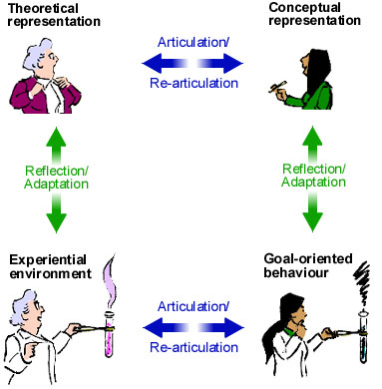

Hence, while correspondence education has existed for over 120 years now, the special expertise of our scholarly teachers is our special strength which we can use to our advantage to attract learners to our institution – both for our expertly designed courseware and the insightful conversations between our teachers and students.

COURSE DESIGN TEAM
Before we launch into the specifics of the multimedia instructional design method used for Internet-optimized courses, we make brief mention of the team required for the different stages of the course lifecycle. The course lifecycle requires a course team comprising certain types of expertise which we at Mona have been quietly developing. Some of the expertise required includes:
- instruction design
- copy editing
- multimedia design
- multimedia application development
- webpage authoring
- programming
- human-computer interface design
- project management
- assessment of learning
- course evaluation
- subject matter expertise.

Resource constraints dictate that members of the course team demonstrate and exercise multiple expertises during the course lifecycle. Instruction Support Systems (ISS) has in practice encouraged course teams of two instructors/subject matter experts (SMEs), and three ISS staff members to provide the other required expertise at the different stages of the course lifecycle. This approach also facilitates the inclusion of personnel from outside the Academy, for example practitioners and employers, as part of the course design team, although this has not been the standard practice up to this point. We are especially keen to engage psychometricians as part of our development lifecycle. We purposefully include and retain trained teachers for our development teams.

This is an opportune time to clarify certain terms frequently used in course design. The academic charged by his/her head of department with re-designing the course is known as the Subject Matter Expert (SME). His/her academic colleague who also attends course design meetings is known as the Academic Peer. The SME or Academic Peer may or may not be the Instructor for the course, that is, the academic who leads the course online or face-to-face (though s/he frequently is).

The course team itself is a valuable enhancement to the quality assurance mechanisms, including as it must, persons who do not teach the course and quite likely have never taken the course. Throughout the course design phase, the dialogue between the SME and the Academic Peer and the ISS staff members as they work to develop the course clarifies and makes explicit many facets of the course that may have been under-emphasized before. In that regard, the SMEs who have worked with ISS have unanimously declared the process educational and exciting and for that we are truly gratified.

COURSE DESIGN
The course design process employs a course design pyramid to illustrate a top-down approach that emphasizes the primacy and integrative aspect of the Goal.

Illustration of the Course Design Pyramid

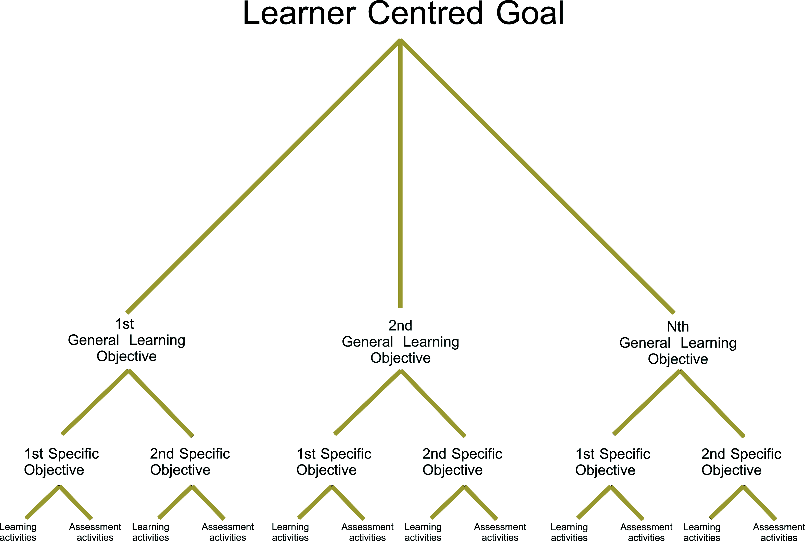

- The Goal is a single holistic statement which concisely informs the student - and by extension, his/her potential employer - of the holistic activities the student can be expected to perform on successful completion of the course. It provides for students the answer to the question, “If I complete this course, what new knowledge, skill or ability will I be able to use for my future development?” It answers for the employer, “If I hire this graduate who has completed this course, what can I expect him/her to be able to do immediately or in the short term?” The Goal addresses the need to develop transferable work skills in our students, and must be carefully formulated, since the main body of the course is derived from the Goal. The main body of the course is generated by answering the question, “What knowledge, skills or abilities does a student need to develop in order to meet this Goal?”

- The answers to these questions are the General Objectives of the course, and typically correspond to modules of one or two weeks’ duration in a semester long course. At this stage of creating General Objectives, course designers who have taught the course face-to-face for a while reflect on the content they usually teach and decide whether to omit any of this content which does not logically flow from the course Goal and therefore appears ‘out of place’, or to modify the course Goal to accommodate this content. (Instructors who are re-designing their face-to-face courses must guard against ‘intellectual ruts’, that is, falling into familiar patterns of content selection which, while comfortable, may need updating or a complete re-vamping. Hence, the course Goal should be modified if - and only if - it is found to be truly deficient and not merely to accommodate the SME’s customs.) The desirable competencies identified for the graduate profile should also be reviewed with a view to adding or subtracting from the selection of General Objectives, to contribute to the development in the student of the desired competencies.

- The answers to these questions are the Specific Objectives of the course, and typically correspond to modules of one or two weeks duration in a semester long course these objectives must be stated in behavioural terms, specifying - as the teacher-trained among us would recall - the audience, behaviour, condition and degree (ABCD). Thereafter, each Specific Objective is codified according to the categories contained in Bloom’s domains of learning. This codification allows the design team to see whether the majority of the course, as suggested by the graduate profile and measured by the number of objectives or the student time on task estimated by the SME, facilitates development of the higher order thinking skills specified as analysis, evaluation and synthesis by Bloom et. al.

- In the next stage, Assessment Activities are designed. Assessment Activities are designed before Learning Activities so that the design of the learning activities will be informed by the pre-existing Assessment Activities. This sequencing also helps the design team to identify the performances that will be required of our graduates whether in industry or further scholarly work which may be used to assess their learning – those activities described in the educational literature as authentic performances. Authentic performances typically allow the assessment of multiple specific objectives, for which rubrics or checklists need to be constructed for grading purposes. Thinking about Assessment Activities first allows us to integrate assessment into the learning process itself, since authentic performances require authentic Learning Activities. Authentic Learning Activities are those activities which require students to solve ill-structured problems similar to those they will tackle in the real-world. Instructors provide coaching and guidance to learners as they engage themselves in soling the problems. These problems may be as simple as case studies or as complex as medical diagnoses of actual patients or different kinds of projects. The Learning Activities must of course provide students with adequate preparation for the Assessment Activities.

- As identified in the earlier discussion of the instructor role, students can be helped to learn verbal information and procedural knowledge by more traditional didactic means. During the instruction design process, those Specific Objectives are best addressed by more directed approaches. Assessment Activities for these Specific Objectives must still be developed before the Learning Activities, which helps to prevent students being assessed at levels inappropriate to their levels and modes of learning given the Learning Activities planned for them. Each Specific Objective in a course design must be addressed by at least one Assessment Activity. Assessment Activities for Specific Objectives taught by directed approaches should be designed to discriminate among Specific Objectives to potentiate targeted remediation. Regardless of the type of Assessment Activity designed, the Learning Activity should prepare the student for it, both in terms of the expectations the Learning Activity generates and the knowledge, skills and abilities developed through the Learning Activity. Both Assessment and Learning Activities should target the same Bloom’s category.

In designing Learning Activities, the graduate profile of desired competencies suggests a range of appropriate teaching/learning methods. ISS guides the instructor in conceptualizing transformative or conversational Learning Activities that exploits the power of the interactive multimedia (IMM) and ICT available to us. We employ Howard Gardner’s multiple intelligences theory as well as the empirical research findings on multiple channel learning and learning styles – both instructors’ and students’ – to guide the design of Activities. While these pedagogical aspects are frequently unfamiliar to SMEs without teacher-training, the non-threatening, supportive framework in which this discipline is put to work provides a familiarization process that positively influences the quality of instruction across course types. We note with gratitude the collaborative contribution of the Instruction Development Unit (IDU) in this area and the projection for continued collaboration in developing and implementing additional curricular support for the teaching departments.

When the Learning and Assessment Activities are completed, the academic department must review the Instruction Design and suggest any necessary changes. Wherever possible, this step is synchronized across all re-designed courses to facilitate a programme review. The project manager and SME then discuss the dates on which the SME will provide the teaching, learning and assessment materials. An instructional designer also makes an appointment to create the pre-test/post-test with the SME. In the next stage, Assessment Activities are designed. ISS has developed both extended response and multiple choice instruments for this purpose. Based on students’ performance in the pre-test, the instructor can emphasize different knowledge, skills and attitudes (KSA) in the course, at the cohort level or in dialogue with individual students. (Teacher-student ratios will clearly affect the range of feasible responses.) The same test is administered after the course has been delivered so that the courses’ impact on the targeted KSA can be measured. This test can be used as a summative assessment or in conjunction with the more traditional types of summative assessments.

The VLE delivers the capability to capture and process many data points. These data become input for informatics that may be used to direct both teachers and learners. ISS provides instructors with item-level metrics such as item-facility, item difficulty, item discrimination, R-biserial and standard deviation. Test-level metrics, such as standard errors of measurements, reliability coefficients, and ‘speededness’ data are also being developed for further assessment and response.

The practice recommends that a multi-person academic team - preferably 4 persons - rather than a single SME will produce the course materials; even though the work involved is well-specified, such a configuration lends itself to cross-pollination of views, which reduces the tendency towards a ‘bunker’ mentality. It is also true that more work is involved in the development of an Internet-optimized course, far more than that required for the corresponding traditional face-to-face course. While the academic team begins work, ISS creates a course container along with the course outline based on the Instruction Design (ID) brief. The ID brief also informs the creation of a Multimedia Design brief by ISS which lists the multimedia learning objects (LOs) to be built, the steps required, the required content and the dates for completion. Hereafter, work begins on these objects, guided by the long-defined principles of message design and multiple channels learning which aims to maximize learning effectiveness and reduce distraction. We also employ elements of human-computer interface theory to maximize learnability and usability. This development is an iterative process in which the SME plays an integral role as critic and guide. The SME/Academic Team reviews the learning objects as they are iteratively developed and improved. Dialogue and exchange between ISS and the academic team continues until all the content has been assembled. Editing then follows after content assembly.

Following editing and departmental approval, the course shall be presented to the Academic Quality Assurance Committee (AQAC) as now obtains. This standard requires and we propose that AQAC make use of a somewhat expanded list of criteria to evaluate the course and make suggestions for its improvement to the department. A list of the expanded criteria shall be provided at a later date.

In addition to the internal peer review provided by AQAC, the UWI can reap the benefit of additional improvements in quality of courseware and teaching, prestige for the institution, and incentives for academic staff by virtue of an elective external peer review process for courseware. We submit that academic staff who devote considerable time, effort and imagination to improve the learning of our students by designing Internet-optimized courses are more likely to receive commensurate recognition and compensation from their peers and the UWI if their teaching scholarship is held to the same rigorous standards as other scholarship. Our opinion is well supported in the scholarly literature - the American Association for Higher Education’s “Peer Review of Teaching” Project, “The Carnegie Teaching Academy: Fostering a Scholarship of Teaching and Learning” project, Thomas Chase’s paper “Online Course Authorship and the Peer Review Process,” presented at the MERLOT International Conference in 2003 - as well as in comments from a discussion on scholarly research and directions led at the IDU’s first seminar in January 2004 by our own Principal, Professor the Honourable Kenneth O. Hall. It is a position embraced and promoted by several thought-leading universities in Australia, the United States and Canada. In our own intuit, simply changing the weighting given to teaching in the assessment of academic staff for promotion purposes, or creating one stream for teachers and another for researchers, may be less effective in changing the relative cultural values currently attached to teaching and research at the UWI in the time it needs to be changed.

External academic peers are already invited and involved in reviewing UWI programmes with oversight from the Quality Assurance Unit (QAU). We believe that this function should be expanded to courseware with a view to appropriating for our teaching staff the relevant values and procedures that have elevated external peer-review to a ‘gold standard’ within the Academy. We propose a peer-review process modelled on that of the professional publications, and similar to that used by SYNTHESIS - an eight-school coalition funded by the National Science Foundation to design, implement and assess new approaches to undergraduate education.

Diagram of Peer Review Process for Courseware
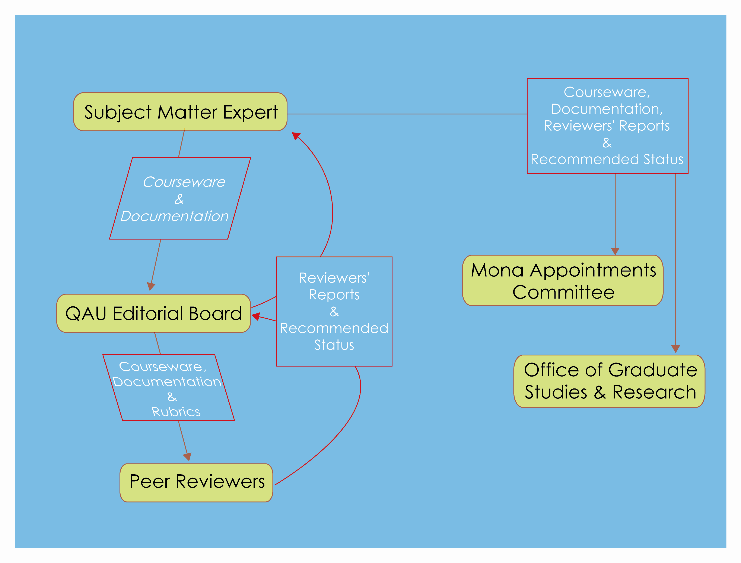

The process would be controlled by a QAU Editorial Board, which after receiving the courseware, will identify external academics with expertise in the courseware’s subject area, and ask them to review its form, content and pedagogy using rubrics provisioned by the Editorial Board after broad consultations with stakeholders. These rubrics should be developed by representatives of ISS, the IDU and other technological and pedagogical experts. Reviewers shall provide a written review on the basis of which the courseware, by majority opinion, shall either be accepted as is, recommended to be revised and resubmitted for review, or remain unendorsed. The SME shall be sent the written reviews and given the option to have this review appended to the courseware’s bibliographic record. We are resolved that this process shall enable the University to apply to courseware similar standards as are applied to professional publications and thus derive the information to assess our standing within the higher education ranks. This same process shall also enable faculty members - the SME’s - who have had their courseware peer-reviewed to clearly demonstrate for their colleagues their contributions to both teaching and research and add to their professional portfolios.

Once the courseware has been delivered for production, learner comments and learning outcomes shall be used as inputs for any modification of the course deemed necessary. When this courseware is hosted in the UWI’s Learning Management System OurVLE, the logs of the sundry asynchronous and synchronous interactions among and between instructors and students working in formal or informal groups can also be peer reviewed by the QAU in a similar manner to that done for our current face-to-face courses.

For all this, we petition your advise and consent.

THE FUTURE
MITS recognizes the institution’s core business functions to be teaching, learning, assessment and research, and in recognition of this has committed a significant portion of the resources placed in our care to developing the campus’ capacity in these areas. Clearly, our efforts in this regard must remain student-centred even as they are faculty-driven. The challenges we face as an institution, including a decreasing budget, increasing competition, questions about our relevance and the quality of our graduates, will not be solved by denial or naysaying. We are required and must learn how to do things differently if we are to fulfil our mandate of ‘unlocking the potential of Caribbean peoples’ in the 21st century. For its part, MITS will engage with educational experts throughout the University even more closely this year than it did last year, and work with the IDU to provide better training for our instructors and instructional design and curriculum review services for all our academic programmes and courses, regardless of the level of technology integration desired by the instructor in the immediate term. We look forward to the support of the Academic Board in these ventures.

By course, we mean the smallest instructional unit assigned a specific number of credits, typically 3, 4, or 6 credits, for example EC10C, P24J, or CA300.
QAA (2000b), Subject Benchmark Statements, Quality Assurance Agency for Higher Education, Gloucester.
The text of the “Joint Declaration of the European Ministers of Education Convened in Bologna” can be found at www.med-net.nl/topics/news/bologna.htm
“Subject Benchmarking and the assessment of student learning,” in Quality Assurance in Education 10 (3), 2002, 155-171
Roblyer, M.A. (2003) Integrating Educations Technology into Teaching, p. 52
Roblyer, p. 56
Courtesy of http://cvu.strath.ac.uk/courses/advac/theory/conversational.html
Bloom, B.S. (1956), Taxonomy of Educational Objectives. Handbook 1: Cognitive Domain, Longmans, London.
www.synthesis.org

