BNCC/DE P.2a
2006-2007

Association of Caribbean Tertiary Institutions Inc.

SUBMISSION TO
THE BOARD FOR NON-CAMPUS SCOUNTRIES AND DISTANCE EDUCATION
(BNCC/DE)
SEPTEMBER 25, 2006
BELIZE

ACTI’S INITIATIVE TOWARD EDUCATION

ACTI
SEPTEMBER 2006

STRATEGIC PLAN

A letter had been written to the Barbados Government requesting a subvention for ACTI, but this had received a negative response; the Ministry of Finance thought that the Barbados Government should not be the only Government to subsidize or give ACTI a subvention, and they also thought that ACTI’s plans for the future should be given time to work.

Dr. Forde, Vice President of ACTI, explained that over the years ACTI operated under financial constraints, and had not shown itself to be a force to challenge major decisions made by the regional decision makers. This was not an impossible task for ACTI, but ACTI needed to harness its power, through its members and put things together, for its various arms such as research. The organization needed to draw on its strengths to become self sufficient and not be dependent. He suggested that ACTI move on with the thought and focus of how we can strengthen ourselves to move forward into becoming a force. The answer was ACTI needed a Strategic Plan.

ACTI NEWSLETTER

It was noted that it is extremely important for ACTI to be well marketed; Dr. Williams reminded the council that CCLCS had volunteered to finance/produce the Newsletter, ACTI News

FUNDING AND MEMBERSHIP

Institutions and individuals want to know how they can benefit from involvement in ACTI. There is a turnover in leadership that had recently occurred in many institutions and ACTI must make a concerted effort to solicit the new leaders to become active (and paying) participants in ACTI.

A New Marketing Drive has become imperative to ACTI’s future success. It is proposed that the AGM 2006 be used as a critical point for increasing membership. We are also looking at improving our communication, so teams were set up to looking these areas and this is how we will address the short coming.

Improve communication/marketing

- redesign of ACTI’s website to include the links of members with websites
Redesign of ACTI Website
Dr G Best – Barbados Community College
Ms. Jacqueline Wade- Caribbean Institute of Technology, Jamaica
Ms. Juliet Reid – ATIB
Mr. Chance – St. Martin

- improve communication between the Membership and ACTI which could be achieved by strengthening the Chapters giving through the appointment of Chapter Heads/Coordinators who would be responsible for coordinating and/or managing communication between ACTI and its membership.

Marketing ACTI through the Chapters

- Barbados
- Bahamas - ATIB
- Belize
- Guyana
- Trinidad - ATITT
- Jamaica - CCCJ
Dominica
St. Vincent
St. Lucia
Grenada
St. Lucia
Antigua

Creating A New Chapter
- The OECS Territories
  - Antigua
  - St. Vincent
  - Grenada
  - St. Lucia
  - Dominica

Marketing Drive through Chapters Marketing

- Invite Non ACTI Member institutions

- Corporate Business

- Government – Ministry of Education

- Press Release

Marketing through Projects

- Caribbean Knowledge and Learning Network (CKLN)

- CARICOM Regional Organization of Standards and Quality (CROSQ)

- Quality Assurance (CTO)

- CARICOM – Regional Accreditation

- GOODWILL

Funds are sought from Agencies

- Application was made to eight funding Agencies

- CDB
- OAS
- IADB
- World Bank
- UNESCO
- CPEC
- UNDP
- CEDA
- DFID

In order to conduct research in different areas such as:

RESEARCH

Link between tourism and spread of HIV/AIDS disease

Coordinator: Mrs. Bonita Morgan – CTO
Dr James Rose – University of Guyana
Dr Henry Anderson - University of Belize
Dr. Chipman-Johnson – Bahamas Community College

Gender – Male v Female Performance in the Academics

Coordinator: Dr Chipman-Johnson - Bahamas Community College
Dr R. Williams – Cipriani College of Labour and Co-operative Studies
Dr Gladstone Best – Barbados Community College
Dr. Henry Anderson - University of Belize
Mrs. Dahlia Repole – Excelsior Community College

Harmonization and Articulation of Associate Degree Programmes to be offered by Regional National/Community Colleges
Coordinator: Dr. Louis Whittington – TLI Unit of the UWI, Cave Hill Campus

Dr. Roosevelt Williams - Cipriani College of Labour and Co- operative Studies

Mrs. Linda Ashton - ACTI

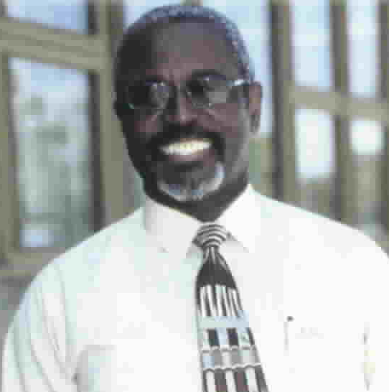

The President
Dr. Roosevelt Williams

invites you

to

ACTI’s Conference and Annual General Meeting

November 6-8, 2006

in Kingston, Jamaica

Entitled
“Leadership Development and Succession Planning Throughout the Organisation: Building Tertiary Education to support an Emergent CSME”

With Presentations on:

- Achieving Institutional Quality
- Developing leadership capacity among Teaching and Non-Teaching Staff
- Ensuring continuous leadership at the Tertiary Level
- Creating partnerships and strategic alliances within the region
- Creating Developmental Institutions for CSME

Mark it off in your diary; it is one not to be missed.

Further details to come….

