BNCCDE P.12b

2006/2007

UNVERSITY OF THE WEST INDIES

Board for Non-Campus Countries and Distance Education

Proposal for Policy on Online Education



The University of the West Indies

Proposal towards a Policy

for Online Learning for

Distance Education Students

Draft for Discussion

April 12, 2007

Contents

1. Scope of this Policy 1
2. Current Status of Online Learning at UWI 1
3. Objectives of this Policy 2
4. Challenges Facing UWI 2
5. Vision and Mission of UWI 3
6. Justification for Online Learning 4
7. Vision for Online Learning 5
8. Barriers to Implementation to be Addressed 5
9. Supporting Structure for Online Learning 6
10. Institutional Policies and Standards 6
11. Governance of Online Learning 9
12. Management and Administration of Online Learning 10
Acknowledgements 10
Appendix 1: UWI Draft Vision Statement 11
Appendix 2: Development and delivery of distance education programmes in the Open Campus 12
Appendix 3: Open Campus Management Information System 15
Appendix 4: Projections of distance education courses, programmes and student numbers in the Open Campus 16
Appendix 5: A typical financial plan illustrating costs, income and disbursement of revenue for an online course 18
Appendix 6: Content sharing and collaborative development initiatives 20
Appendix 7: Approval process for distance education programmes (including those delivered online) 21

.

1. Scope of this Policy
In this document “online learning” is defined as the use of Internet technology to enable the learning process.

The proposal in this document is based on the premise that The University of the West Indies (UWI) should have an agreed set of guidelines for academic, senior administrative and professional staff in the use of online learning for distance education students. It does not address the use of online learning for on-campus students, i.e., where online learning is an additional modality for students studying programmes in face-to-face mode at Mona, Cave Hill or St Augustine campus.

The second premise underlying its development is that ultimate responsibility for any online learning policy rests with the Vice Chancellor. However, at an operational level, it is noted that the responsibility for implementing the policy will rest with the Chairs of the Board for Undergraduate Studies and the Board for Graduate Studies and Research, in particular, given those Boards’ already established responsibility for Quality Assurance within the University. Consequently, any shortcomings in this policy should be reported to the Chairs of those Boards, so that the policy can be kept up-to-date and relevant to the activities of the institution.

2. Current Status of Online Learning at UWI
UWI is mindful of the need to expand access to quality education in those Caribbean countries without a UWI campus, to the rural areas of those countries with a UWI campus, and to persons who for other reasons (e.g., work, family commitments) are unable to access higher education provided in a UWI campus, and is seeking media and modes that will facilitate this. In 1992, UWI took a decision to widen access to UWI programmes and courses by incorporating distance education as an integral part of its operations, this being implemented through the University of the West Indies Distance Teaching Experiment (UWIDITE). The core technology used by UWIDITE was audio-conferencing, which linked several remote sites across the region to facilitate the synchronous delivery of selected courses and programmes. The University of the West Indies Distance Education Centre (UWIDEC) was created to continue the work of UWIDITE in 1996 and now comprises three campus offices with headquarters on the Cave Hill campus. These campus offices are themselves part of a wider network that includes thirty (30) centers/sites spread across the fifteen contributing countries to the University plus Turks and Caicos Islands.

At its meeting of November 6th 2006, the Council of the UWI decided to create a fourth campus, an Open Campus. The Open Campus is founded on a re-conceptualization of the outreach sector which has thus far comprised the School of Continuing Studies, the Tertiary Level Institutions Unit and UWIDEC.

UWIDEC has been following and experimenting with the development of online learning over the last decade. It is aware of the opportunities which this new medium of education presents. At the beginning of year 2007, progress in producing online programs is still slow. However, of far greater concern is the tendency for some departments to mount online programs to distance education students without the full involvement of UWIDEC in all aspects of development, delivery and administration. This has led to students receiving inadequate technical, administrative and learning support. Of equal concern is the potential for UWI to find itself offering duplicates or even triplicates of online programs as each department seeks to compete with its counterparts on other campuses.

3. Objectives of this Policy
This policy sets out to specify some guidelines and broad policies which will promote and inform the development of and use of online learning for distance education students in UWI. The policy will provide a basis on which the institution can adopt a standardised and structured approach to the use of this new medium in our daily activities.

4. Challenges Facing UWI

General challenges
UWI faces a number of challenges, including:
- Limitations on financial resources available to the institution;
- Limitations of the physical facilities available to the institution;
- Increasing cost of education – tendency for instructional costs to rise faster than the rate of inflation;
- Demands for education which exceed our current ability to deliver;
- Growing pressures to increase access to education;
- Geographic dispersion that requires alternative means to enable access to education in islands without campuses and in rural areas of larger countries;
- The increasingly competitive nature of the Higher Education marketplace. Students have greatly expanded choices;
- Aggressive recruitment of students by institutions outside the region.

UWI believes that a number of these challenges can be addressed in part by the use of distance education and in particular use of the online modality.

Challenges facing distance education at UWI
Distance education at UWI faces many challenges, which, for practical purposes, can be grouped into four categories, using Whiteley’s (2000) criteria for measuring quality in distance education, viz., academic, administrative, technological and financial.

Academic Challenges
- Motivating academic staff to develop courses in a timely fashion;
- Timeliness in setting assignments, and marking assignments and examinations;
- Preparing staff and students for the shift from synchronous to asynchronous modalities.

Administrative Challenges
Administrative challenges faced by the UWIDEC arise largely from the fact that UWIDEC spans 30 sites in 16 countries, and the fact that UWI utilises three management information systems that are unable to transcend the boundaries of the campuses in which they are located. Specifically these are:
- Facilitating efficient and effective communication;
- Distribution of materials;
- Registration of students;
- Administration of examinations
- Student services (Advising & Support).

Technology Challenges
- Rapid rate at which technology is changing and the ability of the institution to respond to these changes;
- Ensuring that appropriate technology is selected to meet the needs and capabilities of the institution and its stakeholders.

Financial Challenges
- High cost of developing distance education learning resources;
- Large economies of scale are not possible in the Caribbean;
- Large investments of capital are required for technological infrastructure;
- High costs associated with increasing and enhancing student support, adequate staffing and infrastructure.

Challenges facing online learning at UWI
The academic programme development process at UWI is department or faculty-driven. This has often resulted in programmes being developed in isolation from other programmes within the University, with potential synergies missed. Similar courses can be found in various programmes, with little or no attempt by development teams to rationalize such instances into common courses across programmes. Thus, the challenges facing online learning at UWI include:
- Rationalization/harmonization of common courses across programmes and campuses;
- Rationalization of courses, rules and regulations across similar programmes on different campuses;
- Prevention of the triplication of online programmes, e.g. three online B.Ed. or B.Sc. Management Studies programmes.

5. Vision and Mission of UWI
The draft vision includes the following statements:

Technology infuses our learning environment and expands the range and reach of the quality academic programmes we offer.

Through the use of innovative delivery modes we are the primary source of a variety of high quality programmes that enable professional development and life-long learning opportunities for those from under-served communities who do not have ready access to our major Campuses.

(The full draft vision statement is included as Appendix 1.)

The mission
The enduring mission of The University of the West Indies is to propel the economic, social, political and cultural development of the West Indian society through teaching, research, innovation, advisory and community services and intellectual leadership.

Both the vision and mission together with the strategies that have been defined for UWI clearly set out to address the challenges listed above. The existing educational programmes and traditional education media applied by our institution, are only partly meeting these challenges. It is believed and recommended by this policy, that the use of online learning can support the vision and mission of UWI and provide us with additional capability and more effective utilisation of resources to achieve the UWI vision and mission, but only if developments take place within a clearly articulated framework and with a central organizing body.

6. Justification for Online Learning
Through the rapid technological development over the last 10 years, particularly through the extension of the Internet as a medium of communication and a business tool, a new medium of learning has been developed which provides significant opportunities to higher education institutions. There is already a wide acceptance of this new medium of education as an acceptable and viable mode of education. Many institutions and corporate entities have adopted online learning successfully and there is already a large global community of online learners.

In most cases, this new medium of education will be used alongside the traditional media of education in a manner which has become known as “blended learning”. The main justification of online learning is provided through the opportunities which it presents to the university, including:
- Online learning has the potential to enhance traditional face to face education;
- The ability to develop online learning material, known as learning content, in a form that it can be reused over and over;
- The ability to deliver content to increasing numbers of students electronically at little incremental cost;
- The increasing availability of electronic learning material such as e-journals and e-books to support an online learning approach;
- The opportunity provided to students and lecturers to define the time frames for education allowing for increasing flexibility of teaching and learning times;
- Significant cost reductions in the teaching and learning processes including the ability to teach students who are remote from the institution and making use of their own facilities rather than consuming university's facilities;
- Reduced requirement for physical teaching facilities;
- Reduced travel and accommodation costs for students and lecturers.

In all cases, the use of online learning as an approach or mechanism to achieve learning objectives and defined outcomes needs to be carefully considered to ensure that the highest possible quality of education is provided. The role of the Curriculum Development Specialist (or the Instructional Designer) is crucial in this process.

7. Vision for Online Learning
The online learning vision for UWI is to make effective use of this new medium of education to significantly grow our student numbers and increase access to education while maintaining our standards of quality education. This will support our contributing countries’ national goals and our regional goals. Online learning is thus seen as a means of assisting the University to achieve its overall vision and mission.

The vision of UWI for online learning includes:
- The delivery of high quality learning to its target markets within the Caribbean region, with particular emphasis on the UWI 12, rural areas of the campus countries and those people for whom on-campus education is not possible;
- Ensuring student-centeredness;
- Notwithstanding the intra-Caribbean focus, the vision for online learning also targets markets beyond the borders of the Caribbean, the objective being to broaden the reach of the University on the international stage;
- Contributing to the cost-effective use of resources.

UWI aims to take a lead role in developing online learning in the Caribbean and to become the institution of choice for online learning in the Caribbean based on its relevance, quality and reach. In this regard, it will seek both to develop its own institutional capacity and to provide support to its sister tertiary level institutions in the region to do likewise.

The specific objectives for online learning for distance education students at the university are:
- Online learning will form a component of all programmes, where appropriate, by 2012
- The university will grow its distance education student numbers through the use of online learning to 15,000 by the year 2012 (see Appendix 4).

8. Barriers to Implementation to be Addressed
Two main categories of barriers exist for the implementation of online learning at our institution and in our region. These barriers can be grouped as external and internal barriers and include the following:

External Barriers
The main external barrier is the limitations on access to technology and basic infrastructure such as electricity and telecommunications for our students who are the target market for online learning. We acknowledge that access to technology, particularly the Internet, is increasing rapidly. Until broad-based access is available and reasonable bandwidth is in place for home users wishing to study online at the university, we will continue to face limitations and restrictions on our ability to effectively utilise this new medium. In the short-term, alternative strategies will need to be put in place to overcome this barrier. These strategies will include the use of the UWI in-country sites/centres and the provision of technology access to students both on campus and in these centres.

Internal Barriers
The main internal barrier will be our own willingness to change and adopt this new medium as an effective part of both our existing and proposed new programmes. Until the potential of this medium is understood and internalised by our senior managers and academic staff, and until effective and successful examples of the use of technology enabled learning has been seen at the university, we will struggle to see the benefits of broad scale adoption of online learning.

The second major barrier may be access to the funding required to develop online programmes.

Other barriers may include:
- The perception that online learning may not be an acceptable medium to provide quality education;
- The perception that merely placing lecture notes on the Internet constitutes online teaching;
- The challenge of managing online learning particularly the impact of managing remote students.

9. Supporting Structure for Online Learning
UWI has established the Open Campus, which will function as a development, delivery, standard-setting and capacity building body for distance education, especially online learning. In relation to online learning, the specific objectives of the Open Campus will be:
- To promote the use of online learning in current and future programmes of UWI;
- To provide training and development to lecturers and facilitators of online learning programmes;
- To set and monitor standards for the use of online learning from a technological, content and quality perspective;
- To seek opportunities for collaboration and cooperation with other institutions inside and outside of our borders, and particularly with other institutions in the Caribbean, the Commonwealth and the African Virtual University;
- To monitor the use of external providers of services to ensure standards are adhered to and that quality of service is received;
- The creation of an enabling environment to promote online learning, such as making specific scholarships available for online learning students.

10. Institutional Policies and Standards
The implementation of online learning in the institution will be new to many users. As such, this implementation carries the risk of multiple approaches and different methodologies being applied, creating limitations on our ability to share knowledge, skills and even content, across the university. Accordingly, a key responsibility of the Open Campus will be to ensure the development of and adherence to a defined set of standards and processes which will guide the development of online learning content, the structuring of programmes, the technology to support this new medium and the quality of online learning programmes for distance education students.

ICT Policy
A University-wide ICT policy needs to be established to regulate the deployment and use of the ICTs throughout the University community. This policy will need to make specific provision for technology access for on-campus and distance education students and provide the supporting technology infrastructure to facilitate the development and delivery of online learning programmes.

Performance Service Charter
The requirements for online learning will be built into the performance charter proposed for the University. Following are examples of commitments that should be included in such a charter:
- Study material at registration;
- Feedback on assignments and examination results two (2) weeks after being received by examiner;
- 72-hour turn around time on online responses.

Ownership of Intellectual Property
The University already has an intellectual property policy in place. In summary, the policy specifies that material and content prepared under the instruction of the university is owned by the university. This is in line with international best practice as it acknowledges the opportunity for faculty to prepare material in their own time but clearly takes ownership for content prepared under instruction from and paid for (via salary or contract) by the university.

Programmes
A “modular matrix” approach to distance education programme development will be adopted by the Open Campus, as outlined in Appendix 2. In this approach, maximum efficiency and economies of scale are obtained by “re-using” courses/modules in many programmes.

The Open Campus will continue to offer university programmes currently available through the UWIDEC, at least until students now in the system complete their programmes. New distance education programmes will be prepared for online and blended learning delivery and developed to meet needs already identified in contributing countries as well as those identified in subsequent consultations. The Open Campus will collaborate on a continuing basis with Cave Hill, Mona and St. Augustine to expand access to materials already developed by those campuses and suitable for adjustment for blended learning delivery and delivery in other environments. The Open Campus will use UWI campuses and faculty as the priority resource for the development of new curriculum and programmes.

The selection criteria for programmes for online learning for distance education students may include the following:
- The opportunity to significantly extend access to learners in those Caribbean countries without a UWI campus, to the rural areas of those countries with a UWI campus, and to persons, who for other reasons (e.g., work, family commitments), are unable to access higher education provided in a UWI campus;
- Demand for courses and programmes exceeding the university's ability to deliver by on-campus education;
- The opportunity to significantly extend access to learners outside the Caribbean region.

The nature of the online learning in each programme for distance education students will depend on the requirements of that specific programme. Individual programmes could range from only a small component of the programme being technology enabled, to a programme which is offered entirely online.

Staff and Departmental Incentives
The University should clearly articulate its approach for acknowledging and remunerating departmental and individual staff members’ participation in online learning activities. The following are offered for consideration:
- Lecturers and other members of academic and senior professional staff, when functioning as online course developers or as course coordinators, will be remunerated for the conversion of existing courses to online learning offerings, the development of original online learning materials and the coordination and facilitation of the delivery of online learning courses or components of courses where such activity falls outside of the normal responsibilities and workload of the individuals.
- Departments and all academic and senior professional staff will be acknowledged for their contribution to the development and delivery of online programmes and courses.
- All academic and senior professional staff will, against a set of standards to be determined, be entitled to receive credit towards their annual assessment and which will count towards promotion, for all online learning activity that they engage in.
- The fees paid by students will be set so that in most cases revenue earned will cover costs and generate a surplus. In a few cases, special arrangements will have to be made to cross-subsidize courses that do not generate sufficient income to cover their costs.
- The surplus remaining after all costs have been met for a particular course will be shared with the Department responsible for creating that course, in accordance with the financial plan collaboratively developed with that Department (see Appendix 5 for a typical financial plan).

Tutoring
Where online classes are large, there will be need to retain the services of subsidiary teaching staff to assist the lecturer (course coordinator) in managing the delivery of the course and in facilitating the students in their learning. Typically, tutors will be retained as part time members of staff and will be appointed/contracted on the basis of clearly articulated terms and conditions. Existing terms for tutors have been upgraded to cater for the specific requirements of online learning.

Process
Guidelines will be developed to cover the following processes:
- The assessment of programmes to consider their suitability for online learning.
- The process for converting existing courses and for developing original materials.
- The process to be used for delivering courses or components of courses online.
- The administrative process for online learning programmes.

Content development
Online learning content will be developed utilising the institution’s approved content authoring tools and technologies. Content, once developed, will be owned and stored by the University in a format that can be easily reused and shared where appropriate. Over time, the University may wish to join with other institutions in the establishment of a Learning Object Repository (LOR) that will be the primary medium for storing individual elements of content. In this regard, it is important to note the content-sharing initiatives currently being developed through the Caribbean Universities Project in Integrated Distance Education (CUPIDE), the Caribbean Knowledge Learning Network (CKLN) and the Virtual University of Small States of the Commonwealth (VUSSC) Project (see Appendix 6 for details of these initiatives).

In any such undertaking, the following are proposed as key elements of the governing policy:
- The University will own all content.
- The University will continue to use a combination of internal resources and contracted out resources for course development.
- In line with the intellectual property policy of the institution, online content developed specifically for the University as instructed by the University will belong to the institution. The individuals and departments developing this content will be acknowledged for their contribution.
- Online content development:
  - Will count towards individual promotion; and,
  - Can be referenced in a publication or CV.
- The source of materials adapted or adopted from other institutions will be acknowledged.
- The development of course material must be completed at least two (2) months before it is offered.

Technology
The University currently uses two Learning Management Systems (LMS), namely WebCT (closed-source, proprietary, licensed software) and Moodle (open source, license-free software). The University needs to develop a formal strategy that will specify the use of either one or both (based on well defined criteria) for the future.

The Open Campus is convinced that the use of open source software for these applications would be in the long-term interest of the University for two main reasons:
- To avoid the significant licensing costs and the dangers of lock-in associated with closed-source enterprises;
- An open source LMS such as Moodle allows the user to build features relevant and specific to the user’s needs, while maintaining a fairly consistent look and feel.
It is also felt that in-house initiatives should be encouraged.

Assessment
The existing institutional policies and rules for courses assessment will remain applicable to online learning programmes, though the actual assessments will be adapted to reflect this mode of delivery.

11. Governance of Online Learning
The use of online learning as a new medium for the provision of distance education should not change the existing Governance and approval processes of the university. In particular, the following key policy statements form the basis of governance of these programmes:
- The approval of programmes for online learning, including the implementation of modifications to existing programmes to blended learning into the current approach, requires the approval of the Board for Undergraduate Studies or the Board for Graduate Studies and Research, as would be the normal case with any other changes to all proposed new programmes (see Appendix 7).
- All programmes proposed for online learning should be supported by a sound business, marketing and financial plan to assist in ensuring the viability of the programme.
- The Open Campus will be responsible for ensuring the standards for online learning content development and presentation are adhered to.
- The Academic Quality Unit retains its existing responsibility for the academic quality of all programmes presented by the university.
- All programmes should ideally be evaluated by both internal and external reviews to assist in the quality assurance process.

Where necessary, the unique requirements of online learning for distance education students will be accommodated in the Governance and Policy framework of the university.

12. Management and Administration of Online Learning
The management and administration of online learning activities for distance education students will be consistent with the existing processes and procedures of the university. Where required, policies and procedures will be developed or modified to deal with the unique requirements of these programmes and specify the manner in which online learning programmes will be managed by the institution.

The success of online learning for distance education students is dependent on the co-operation and collaboration of numerous parties including the lecturers, the course designers, the content developers, the course administrators and facilitators and the ICT function. Effective management processes will need to be put in place to ensure this co-operation.

A totally integrated management information system (MIS) is an essential prerequisite for the effective management and administration of Online Learning. For this reason, the Open Campus has built its own MIS based on open source code (see Appendix 3).

Acknowledgements
This draft document was written with the benefit of an earlier document “Proposal for an eLearning Strategy and Policy for The University of the West Indies (UWI)”, the latter being the output of a workshop on eLearning that was conducted by the Commonwealth of Learning (COL) for the benefit of academic and senior professional staff of the St. Augustine campus. The earlier document was written prior to the establishment of the Open Campus and so in many respects is superseded by the current document. However, please also note that the earlier document also deals with eLearning for on-campus as well as distance education students, whereas the current document deals only with online learning for distance education students.

Professor Stewart Marshall
April 12, 2007

Appendix 1: UWI Draft Vision Statement
In 2012, the UWI degree is the standard of excellence in tertiary education in the region and the UWI is recognized as a learning institution that meets global performance standards in research and graduate and undergraduate teaching and learning. It has enhanced its position as the premier tertiary educational institution within the region, the first choice institution for the region’s students, the leading advocate of an expanded and articulated tertiary education system and an agent for regional social, cultural and economic development.

We have made major changes in our curricula and in the way we teach and assess learning. Our programme offerings are varied and flexible. Technology infuses our learning environment and expands the range and reach of the quality academic programmes we offer. Our students move seamlessly throughout the entire university to achieve their educational goals.

Our graduates are career-ready, exceptionally well-grounded in their disciplines, articulate and possess superior problem solving and critical thinking skills. They are socially conscious, regionally responsive, well-rounded, committed to ethical behavior, globally attuned and able to work effectively, both independently and in teams.

We are responsive to national needs yet retain a strong Caribbean identity and operate as a single regional university in continuous dialogue with national stakeholders. Through the use of innovative delivery modes we are the primary source of a variety of high quality programmes that enable professional development and life-long learning opportunities for those from under-served communities who do not have ready access to our major Campuses.

We are unquestionably the primary source for research and advice in dealing with the complex issues and challenges facing the region because our expert staff members, who are subject to rigorous performance standards, are engaged in internationally competitive research on issues of concern to the region and beyond, and the results of this research are effectively disseminated.

Our financial health is stable and sustainable because of balanced and diverse funding sources, including income from research, consulting, commercial activity and philanthropic contributions from alumni and others; government support, in the form of multi-year financing arrangements; and student tuition, supported by appropriate loan arrangements.

We have dramatically improved our systems and processes for administration and information support through the appropriate use of technology and benchmarking. They are integrated, user-friendly, and operate in a highly effective manner allowing both staff and students to be the beneficiaries of excellent service.

Our university has become a sought after partner, enjoying productive and mutually beneficial relationships with international scholars from other universities and research institutions, national and other regional institutions, international agencies, organisations in the public, private and non-governmental sectors and the residents of our neighbouring communities.

Our institutional culture is defined by courageous, consensual and effective leadership, an orientation that is results and performance-based, rigorous accountability, and a deep sense of humanity. We value our staff and students by providing for them a truly supportive environment and by rewarding excellence. We are an innovative, modern, international university deeply rooted in the Caribbean, committed to creating the best possible future for all our stakeholders.

Altogether, in 2012, the University of the West Indies enjoys an identity as a unique and well-integrated regional institution. It presents to its various publics, through its programmes and effective marketing, a strong image of a resourceful and innovative university, highly responsive to their needs, and agile enough to thrive in a dynamic environment.

Appendix 2: Development and delivery of distance education programmes in the Open Campus

The University of the West Indies Distance Education Centre
In 1992, the University of the West Indies (UWI) took a decision to widen access to UWI programmes and courses by incorporating distance education as an integral part of its operations. Based on this decision, the UWI was transformed from a single-mode to a dual-mode institution, with the University of the West Indies Distance Education Centre (UWIDEC) being created in 1996 to facilitate this new mode of delivery.

UWIDEC comprises three campus offices with headquarters on the Barbados (Cave Hill) campus. These campus offices are themselves part of a wider network that includes thirty (30) centers/sites spread across the fifteen contributing countries to the University plus Turks and Caicos Islands (see Figure 1).

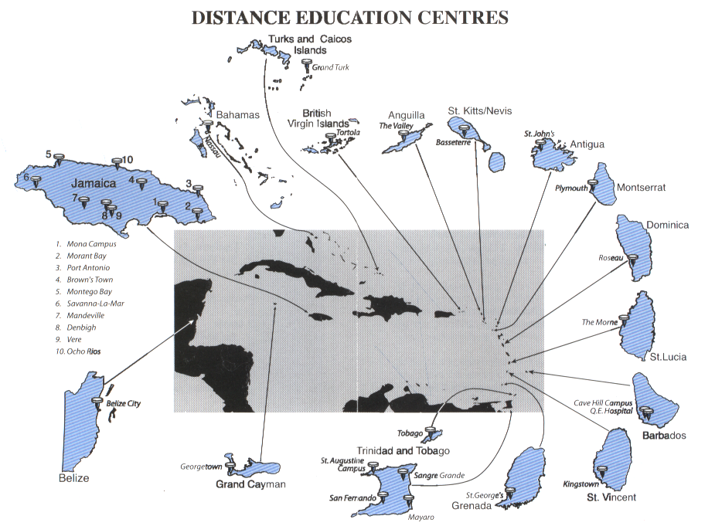
Figure 1: Map indicating UWIDEC Sites

Increasingly, ICT (especially the Internet) is being used in distance education to create learning environments in which learners, tutors and learning resources can all be networked. Adoption of the Internet in the Caribbean, however, significantly lags behind that in the United States and other developed countries. Also, Internet adoption is uneven within the Caribbean region, for example, in 2003 approximately thirty-seven (37) percent of the inhabitants of Barbados were Internet users compared to six (6) percent for St Vincent and the Grenadines, and one (1) percent for Haiti and Cuba. Given this low and uneven adoption of ICT in the region, in the short term it is necessary for UWIDEC to provide access through its sites. Each site is equipped with one or two audio-conference rooms as well as a computer laboratory of at least ten (10) computers that are connected in a local area network. These computers are installed with Microsoft Windows and Office Professional software, and have multimedia capabilities.

UWIDEC now employs a mix of media in the delivery of the university’s distance programmes, with pre-packaged print materials being the core component supported by some face-to-face and audio-conferencing tutorials, but with an increasing emphasis on asynchronous modalities: CD-Roms, e-tutorials, course websites and other online support.

In 2004 UWIDEC decided to move from WebCT to an open source Learning Management System (LMS) ”Moodle” for all future online course elements. This decision was based on assessments conducted by both the UWIDEC Web Administrators and Mona Information Technology Service of various open source learning management systems. The assessments considered usability features and help facilities, support for technology staff, customizable look and feel and discussion forums, email, file exchange, synchronous messaging, calendar, automated testing and scoring, group work, student tracking. The two main reasons for switching to Moodle were firstly to avoid the significant licensing costs and the dangers of lock-in associated with closed-source enterprises. Secondly, and perhaps more important is the fact that learning management systems are constantly evolving. An open source LMS such as Moodle allows the user to build features relevant and specific to the user’s needs, while maintaining a fairly consistent look and feel.

Moodle is an Australian product currently used by more than 2000 educational organizations around the world to deliver online courses and to support face-to-face courses, including the UK Open University and Athabasca University. Moodle has two meanings. The first is Modular Object Oriented Developmental Learning Environment and the second, is Australian slang, which means “to toss around an idea in your head for a while to look at different aspects of it.

Development and delivery of distance education programmes in the Open Campus
The academic programme development process at UWI is department or faculty-driven. This has often resulted in programmes being developed in isolation from other programmes within the University, with potential synergies missed. Similar courses can be found in various programmes, with little or no attempt by development teams to rationalize such instances into common courses across programmes. Although Academic Boards can comment on the need to capture such synergies, the reality is that very little is achieved at Campus-level, let alone at University-level, by way of economies resulting from course rationalization. The University can ill-afford the wasteful duplication of similar courses, and instead should seek to create economies of scale of enrolments in each course by designing it as re-usable in several programme contexts. This is particularly the case for postgraduate programmes offered in the “UWI-12” countries, where enrolments in each programme in each country are small in number.

Using the platform described in the section above on the University of the West Indies Distance Education Centre, the Open Campus of UWI in the future will provide education that is:
- Economically designed – doing more with the same resources and working “smarter”;
- Relevant - to the needs of students, employers and society;
- Flexible, in respect of:
  - Time - students can enrol and study at anytime;
  - Place - students can enrol and study anywhere;
  - Mode - study can be anywhere on the continuum from face-to-face to totally online;
  - Product – programmes “tailor-made” and created quickly;
- Scaleable, i.e., enable us to move from offering a course to 30 people to offering it to 3000 people;
- Collaboratively created and delivered - forging strategic partnerships and collaborations with others, both within and outside UWI, to maximise our teaching outputs and scaleability;
- Quality assured - products and processes based on best practice and research.

Paradigm changes in both programme development and course delivery are central to the successful achievement of the above.

A “modular matrix” approach to programme development
The “modular matrix” approach to programme development, shown in Figure 2, is one that views a programme as comprising courses or parts of courses selected from a database or matrix of courses, modules and other learning objects.

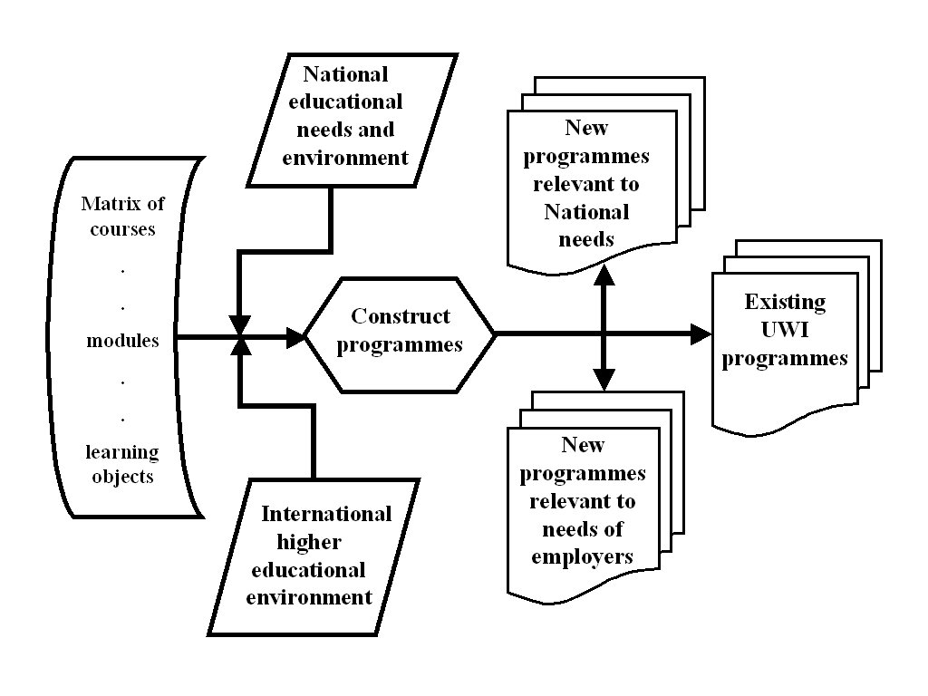

Figure 2: A flexible modular matrix system to create programmes

From such a matrix, it is possible to rapidly construct programmes in response to the changing HE environment, including:
- The existing UWI programmes;
- Programmes relevant to National needs;
- Programmes relevant to employers needs;
- Programmes relevant to the needs of students in the information society; and,
- Whatever other programmes are required at anytime, given that the higher education environment is constantly changing.

By judicious choice of existing UWI courses and parts of courses (modules and learning objects), it would be possible to create a matrix that would generate the full range of programmes currently offered, plus many more, in a more economical way.

Appendix 3: Open Campus Management Information System

Discussion
A totally integrated Management Information System (MIS) is essential for the efficient and strategic operation of the Open Campus. It must facilitate input of information by the distributed group of information-owners and permit appropriately approved access by a distributed group of stakeholders. To meet these needs, the MIS will be custom-built and comprise the following components: Student Management System (SMS), Country/Site Information System (CSIS), Human Resource Management System (HRMS), Learning Management System (LMS), Financial Management System (FMS), Website Management System (WMS).

All the components will need to "talk" to one another in “real time” in order to maximise the benefits of using ICT. For example, the WMS will automatically populate web pages on the Open Campus website with information extracted from databases of site, staff and course information in the CSIS, HRMS and LMS. This WMS will also create an individualised portal for each student with information extracted from the MIS component systems, e.g., providing a list of the courses in which the student is enrolled, enabling the student to click on a course to obtain the contact details for the coordinator and tutor, their assignment results, etc. Similarly, the WMS will create individualised staff and country/site portals.

Wherever possible, existing systems - either proprietary or open source - will be used for the components of the Open Campus MIS, e.g., “Moodle” (an open source product) will be modified for use as the Open Campus LMS. But in some cases it will be necessary to purpose build the component system, e.g., the Open Campus SMS.

The three existing campuses of the UWI use BANNER as their student management system. Why is Open Campus going to use different SMS from campuses?

The Open Campus of the UWI will not use BANNER as its SMS because BANNER has been demonstrated to be deficient in meeting the demands of a distributed environment such as that which the UWIDEC system must cater for. The deficiency of BANNER for such an environment was demonstrated when the University was obliged to decide that it would implement three instances of BANNER, one for each campus because of access difficulties using a single instance remotely.

The UWIDEC (now absorbed into the Open Campus) undertook the development of a management information system suitable for use in a distributed environment allowing data entry and management as well as the generation of reports from any Internet access point. The system is robust, resistant to tampering, easy to use and completely adapted to the environment in which the open campus will be operating.

Resource file:
BNCCDE 2004-2005 Paper 13b “UWIDEC's Information Management System” http://www.uwichill.edu.bb/bnccde/boardmeetings/200452/20045P13bUWIDEC_management_system.doc

Appendix 4: Projections of distance education courses, programmes and student numbers in the Open Campus
In the following sections, 2005-6 is taken as the base year and projections are made for distance education programmes and student numbers in the Open Campus for two years and five years thereafter.

Year 2005-2006:

DE Student enrolments in UWIDEC: 2,745

Courses available in blended learning format: 15 UWI degree-level courses; 1 undergraduate certificate level.

Year 2008-2009:

Projected DE student enrolments: 5,000

The following programmes will be available online or in blended learning format:

Undergraduate Certificates & Diplomas:
Certificate in Drug Reduction in the Caribbean
Certificate in Communication Information for Development
Diploma in Gender Studies

Undergraduate Degrees:
B.Ed. Education Administration
B.Ed. Literacy Studies
B.Sc. Accounting (Level I)
B.Sc. Banking and Finance
B.Sc. Economics (Level I)
B.Sc. Management Studies
B.Sc. Tourism
B.Sc. Nursing

Postgraduate Certificates & Diplomas:
Advanced Diploma in Construction Management

Postgraduate Degrees:
M.Sc. Counselling
M.Sc. Family Medicine
MA Caribbean Studies
M Adult Education

Year 2011-2012:
Projected DE student enrolments: 15,000

The following programmes will be available online or in blended learning format:

Undergraduate Certificates & Diplomas:
Certificate in Drug Reduction in the Caribbean
Certificate in Communication Information for Development
Diploma in Gender Studies

Undergraduate Degrees:
B.Ed. Education Administration
B.Ed. Teaching
B.Ed. Literacy Studies
B.Sc. Accounting
B.Sc. Financial management
B.Sc. Agribusiness and Management
B.Sc. Banking and Finance
B.Sc. Economics
B.Sc. Management Studies
B.Sc. Tourism
B.Sc. Nursing

Postgraduate Certificates & Diplomas:
Postgraduate Diploma Construction Management
Postgraduate Diploma Instructional Design Technology
Postgraduate Diploma International Business
Postgraduate Diploma Information Systems
Postgraduate Diploma Information Technology
Postgraduate Diploma Business Administration
Postgraduate Diploma e-Business
Postgraduate Diploma Banking and Finance
Postgraduate Diploma Financial management
Postgraduate Diploma Marketing Management
Postgraduate Diploma Records management
Postgraduate Diploma Human Resource Management
Postgraduate Diploma Tourism Management
Postgraduate Diploma Information & Communication Technology for Development
Postgraduate Diploma Project management

Postgraduate Degrees:
M.Sc. Counselling | M Business Administration
M.Sc. Family Medicine | M e-Business
MA Caribbean Studies | M Banking and Finance
M Adult Education | M Financial management
MEd Instructional Design Technology | M Marketing Management
M International Business | M Human Resource Management
M Trade Policy | M Tourism Management
M Information Systems | M Information & Communication Technology for Development
M Information Technology | M Project management

Appendix 5: A typical financial plan illustrating costs, income and disbursement of revenue for an online course
In the following typical financial plan, a programme comprising 10 courses is developed to be offered online to 50 students in a cohort. It is assumed that a further two cohorts will take this set of courses before they are redeveloped, and so the development costs are amortized over three offerings. It is further assumed that an upper limit of 25 students is set for each e-tutorial group. The course fee for each 3-credit point course in this programme is set at US$300.

On this basis, each offering of the programme results in a surplus of US$63,183, to be distributed between the Department and the Open Campus on a previously agreed basis.

Open Campus+Dept ABC: Financial Plan for Programme EFG
Course Development Costs ($US)
Variables:
Amortize development costs over y offerings, where y = |  |  |  |  | 3
Number of courses: x = |  |  |  |  | 10
Item | Costs |  |  | Cost per Centre
Item | Item Cost | Cost for x courses |  | Dept ABC | Open Campus
Project coordination and administration |  | 4,000 |  | 2000 | 2000
Course Writer (development) | 4,700 | 47,000 |  | 47,000
Web developer (promotional website) |  | 1,450 |  |  | 1,450
Asst. Instructional design/Editor | 1,300 | 13,000 |  |  | 13,000
Web developer (Moodle LMS) | 1,500 | 15,000 |  |  | 15,000
Curriculum Development Specialist | 1,500 | 15,000 |  |  | 15,000
Total Development Costs |  | 95,450 |  | 49,000 | 46,450
Development costs per offering of x courses |  | 31,817 |  | 16,333 | 15,483

Course Delivery Costs ($US)
Variables:
Number of students: z = |  |  |  | 50
Maximum number of students per e-tutorial group: m = |  |  |  | 25
Number of e-tutorial groups: n = |  |  |  | 2
Item | Costs |  | Cost per Centre
Item | Item Cost | Cost for x courses | Dept ABC | Open Campus
Course Coordinator (delivery) | 1,700 | 17,000 | 17,000
Tutor | 1,150 | 23,000 | 23,000
Registrarial System & Support | 500 | 5,000 |  | 5,000
Financial System & Support | 500 | 5,000 |  | 5,000
Technological System & Support | 500 | 5,000 |  | 5,000
Total Delivery Costs for z students |  | 55,000 | 40,000 | 15,000
Development & Delivery Costs (US$)
 |  | TotalCost | Dept ABC | Open Campus
Total Development & Delivery Costs for z students per offering of x courses |  | 86,817 | 56,333 | 30,483
Income (US$)
Fee per course $USfee = |  | 300
Total Income = US$fee * z students * x courses |  | 150,000
Surplus (US$)
Surplus per offering |  | 63,183

Appendix 6: Content sharing and collaborative development initiatives

Caribbean Universities Project for Integrated Distance Education (CUPIDE)

Implementing Agency: | The University of the West Indies
Funding Agency: | Japanese Funds-In-Trust for Capacity Building
Executing Agency: | UNESCO
Project Start Date: | January 20, 2003
Completion Date: | December 31, 2007
Project Director: | Professor Stewart Marshall  Director, Distance Education Centre, The University of the West Indies.
Project Operations Manager: | Ms. Christine Marrett  Distance Education Centre, The University of the West Indies.
Website: | http://cupide.dec.uwi.edu/
Background: | The development objective of the project is to develop the human resources within the region through enabling each of the five participating universities to develop and deliver quality distance education programmes using information and communication technology (ICT). In this way, the competitiveness of the region in general and the institutions in particular are to be enhanced, participation in the knowledge society increased - not only as users, but also as generators of knowledge - and cost savings realised in the use of the technology for distribution of the course materials and the teaching and administration of programmes. Collaboration among the participating institutions is also to be enhanced in order to facilitate content sharing and collaborative development of courses and programmes.

Caribbean Knowledge Learning Network (CKLN)

The goal of this five-year, multi-donor project is to leverage information and communications technology and modern approaches to education to enhance the global competitiveness of countries in the Caribbean.
The overall objectives of this project are:
- to improve the relevance of tertiary education and training by increasing the number of accredited tertiary education programs recognized internationally for their excellence.
- to strengthen tertiary institutions, foster specialization and knowledge sharing.
- to ensure the convergence of fragmented regional and international initiatives to maximize results in the region as well as the international market.
The CKLN will eventually benefit all public tertiary education institutions in the CARICOM countries (an estimated 150 Tertiary Institutions) including the University of the West Indies (UWI).

Website: http://www.ckln.org/

Virtual University for Small States of the Commonwealth (VUSSC)

The Commonwealth Education Ministers conceived the idea of the Virtual University for Small States of the Commonwealth (VUSSC) at their meeting in Halifax, Canada, in 2000. The Commonwealth of Learning extended a formal invitation to the Education Ministers of the small states to particpate in this initiative aimed at expanding access to education enabled by appropriate ICTs. VUSSC member countries met in Singapore on two occasions signing a Letter of Intent as well as the Singapore Statement.

The VUSSC is a network committed to the collaborative development of free content resources for education.

Websites:
http://www.wikieducator.org/VUSSC
http://www.col.org/vussc/

Appendix 7: Approval process for distance education programmes (including those delivered online)

Current Approval Process

UWIDEC
BGSR
or
BUS
Faculty
of
ABC
BNCC&DE
Academic
Programme
Committee

Proposed Approval Process with Open Campus

Curriculum
Division
BGSR
or
BUS
Faculty
of
ABC
BNCC&DE
Open
Campus
Academic
Board

It has been agreed that UWIDEC (and hence the Open Campus) will use its own student administration system for real-time interaction with the rest of the UWIDEC information system, but will also push the same student data into an instance of BANNER.

